**Partnership and Sponsorship Analytics - Entertainment Sector**

Pooja Joshi & E.Code [E25007]

# Overview :

# This report presents an analysis of partnership and sponsorship strategies within the entertainment sector. The focus is on assessing key metrics that influence the success of various media types and understanding audience engagement trends based on sponsorship initiatives.

# Objective:

· To assess the impact of sponsorship on media performance.

· To identify trends in audience engagement based on sponsorship initiatives.

# Assigned Task(s) :

· **Data Cleaning and Preprocessing**: Prepare the dataset for analysis, focusing on missing values and outlier management.

· **Exploratory Data Analysis (EDA)**: Analyze key metrics such as popularity, vote averages, attendance count, and sentiment analysis.

· **Predictive Modeling**: Develop a model to predict the impact of sponsorship initiatives based on audience engagement metrics.

# Task Details :

**Task 1: Data Cleaning and Preprocessing**

* · **Status**: Completed
* **Details**:
  + Loaded the dataset and identified columns such as valuation, popularity, vote_average, and attendance_count.
  + Cleaned the data by removing entries with missing or null values, ensuring that the dataset was ready for analysis.

· **Task 2: Exploratory Data Analysis (EDA)**

* **Status**: In Progress
* **Details**:
  + Analyzed key metrics by grouping data based on available columns such as original_title, popularity, vote_average, and attendance_count.
  + Created visualizations (e.g., bar charts and scatter plots) to display average popularity and attendance based on various attributes.
  + Examined sentiment analysis results from the sentiment_scores, compound_score, and sentiment_label columns to understand audience reactions.

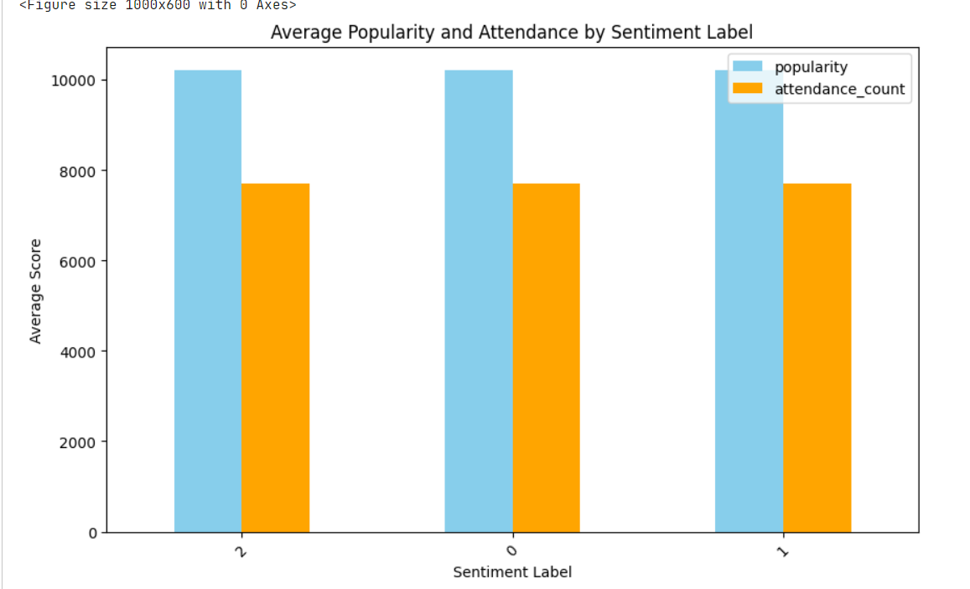

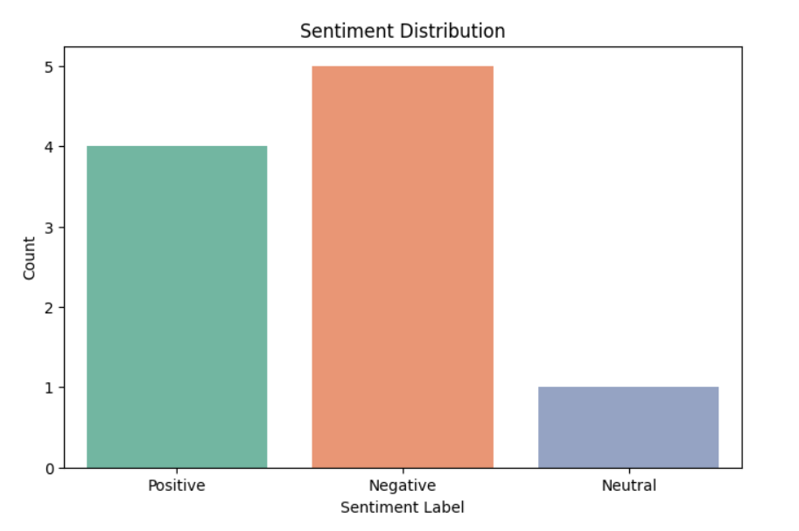

· **Task 3: Predictive Modeling**

* **Status**: In Progress
* **Details**:
  + Prepared features (X) and target (y) variables for modeling, focusing on relevant metrics like popularity, attendance_count, and vote_average.
  + Built a linear regression model to predict the impact of sponsorship initiatives on key performance indicators.
  + Encountered challenges with variable types in sentiment_scores, requiring additional preprocessing to convert string data into numerical format.

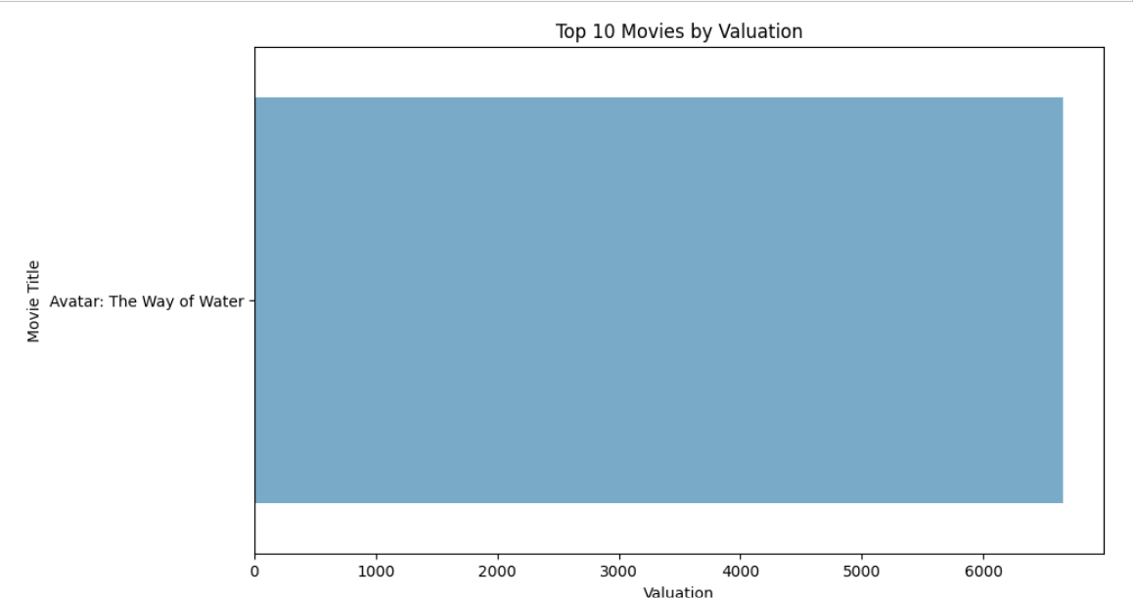

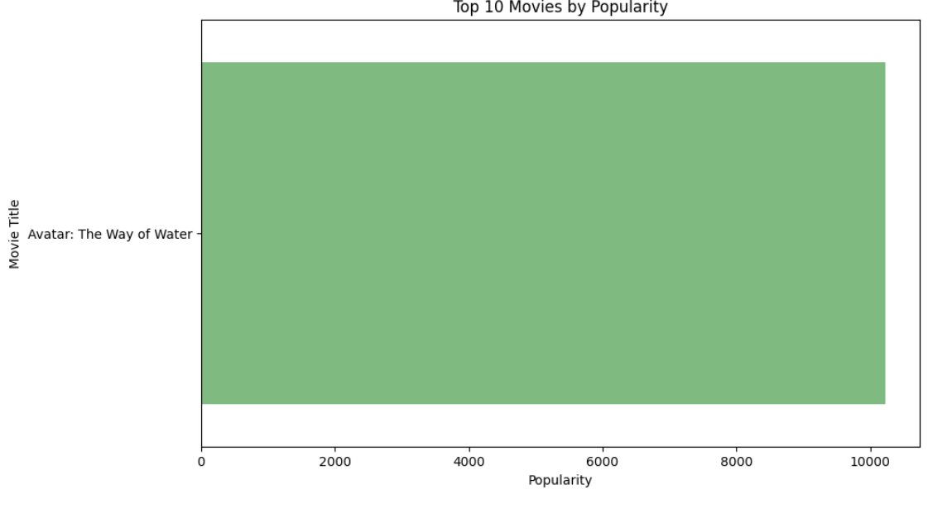

· **Task 4: Visualization**

* **Status**: In Progress
* **Details**:
  + Developed various visualizations to represent the data analysis, including:
    - Bar charts to show the relationship between popularity and attendance_count.
    - Scatter plots to analyze the correlation between vote_average and popularity.
    - A time series plot (if release_date were available) to examine trends over time

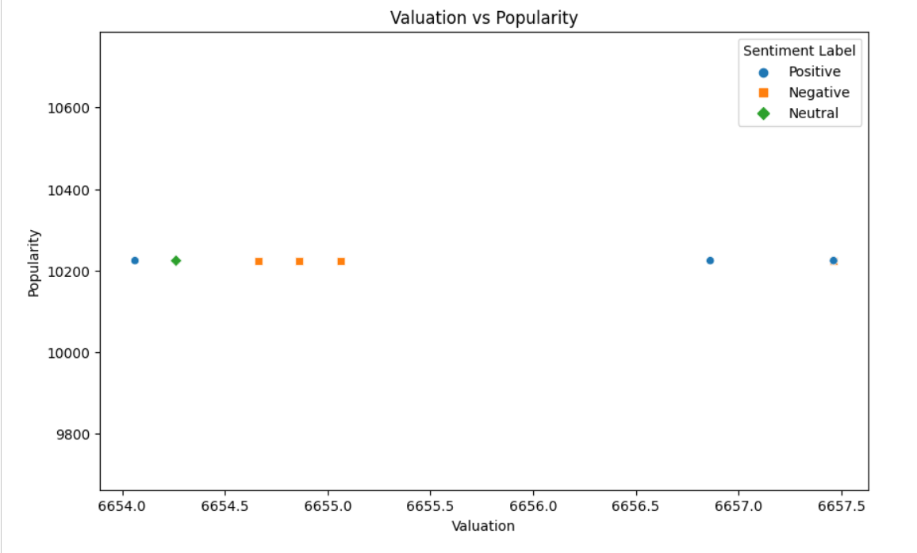

# 

# 

# 

# 

**Progress :**

· **Accomplishments**: Successfully cleaned the dataset, conducted EDA, and initiated the development of the predictive model.

· **Metrics**: Key metrics analyzed include average popularity (mean), vote averages, and attendance counts across different media types.

# Challenges and Solutions :

· **Challenges Faced**: Encountered missing columns (e.g., release_date and media_type) which impacted initial analysis plans.

· **Solutions Implemented**:

* Adjusted the analysis to focus solely on available metrics and their relationships.
* Implemented preprocessing steps to handle string data in sentiment analysis for modeling.

# Next Steps :

· **Upcoming Tasks**: Complete the predictive modeling, finalize EDA, and interpret the results to provide actionable insights.

· **Goals**: Set clear benchmarks for evaluating the effectiveness of sponsorship initiatives in the entertainment sector and prepare a presentation for stakeholders.

.

# Conclusion :

# Summary: This report outlines the key stages of our partnership and sponsorship analysis, focusing on data cleaning, exploratory analysis, and initial modeling efforts.

# **Acknowledgments**: Thank the audience for their time and attention.